Introduction – Data Science

**What is Data Science?**

* The extraction of knowledge from large volumes of data that are structured or unstructured, which is a continuation of the field of Data Mining and Predictive Analytics.

**When is Data Science useful?**

* Data Science is only useful when the data are used to answer a specific concrete question.

**The structure of Data Science**

* The process of formulating a question
* Collecting and cleaning the data
* Analysing the data
* Communicating the answer

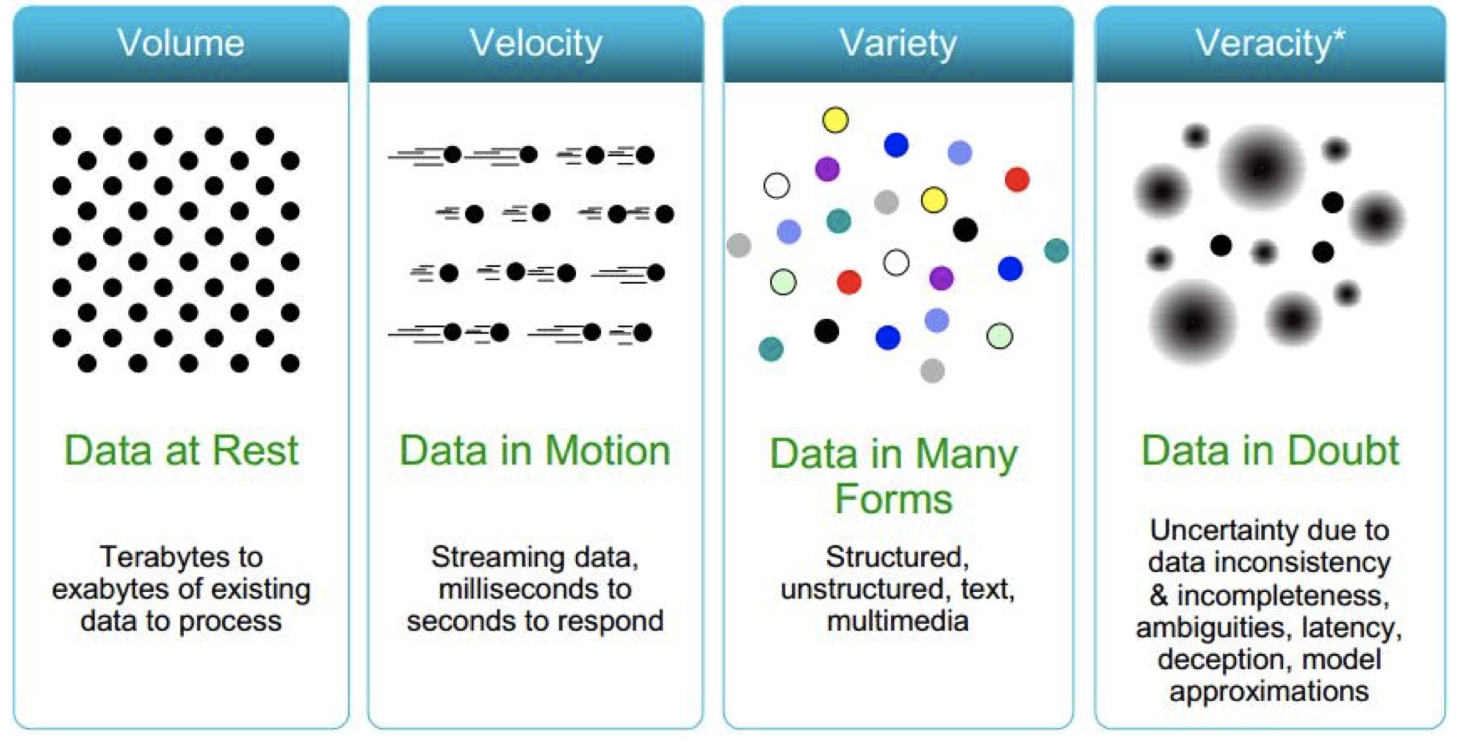

**Why is volume important?**

* We have data we did not have before: GPS coordinates from photos & cars, large genome databanks.
* This data allows us to answer questions we could not answer before.
* Large sets of (human generated) data can replace complex algorithms
  + People leave traces of ‘intelligence’ in the data with their intelligent behaviour on everyday tasks
  + You need a lot of data (specially to cover rare events)

**Why is uncertainty important?**

* If data is factual, answering is straightforward
* However, data must always contain uncertainty
* Therefore, we need statistics to estimate possible solutions to questions.

**Wat is Machine Learning:**

* Computer program that modifies or adapts its actions so that these actions get more accurate/optimal

**Manual engineering becomes infeasible when:**

* Data volume grows
* Data complexity grows (many features)
* There is less time to develop